Febrian Arka Samudra_10_1i

JOBSHEET 7

**Questions 1**

1. There are 3 main components in FOR loop. Based on experiment 1 above, identify and

explain these 3 components!

-initialization: This part is where you initialize a loop control

variable (often referred to as an iterator) to an initial value. It is

executed only once at the beginning of the loop.

• condition: This part specifies a condition that is checked before

each iteration of the loop. If the condition evaluates to true, the loop

continues; if it evaluates to false, the loop terminates.

• iteration: This part is usually an increment or decrement

operation that updates the loop control variable. It is executed at the

end of each iteration, just before checking the condition again.

2. Explain how the following code works!

-

1.for (int i = 1; i <= 50; i++): This line initiates a for loop. It starts with i equal to 1 and continues as long as i is less than or equal to 50. In each iteration of the loop, i is incremented by 1.

2.if (i % multiple == 0): This line checks if the current value of i is evenly divisible by the value stored in the multiple variable. The % operator is used to calculate the remainder when i is divided by multiple. If the remainder is 0, it means that i is a multiple of multiple, and the code inside the if statement is executed.

3.sum = sum + i;: If the condition in the if statement is true, it means i is a multiple of multiple, so the value of i is added to the sum variable. This is done to accumulate the sum of all such multiples.

4.counter++;: After adding i to the sum, the counter variable is incremented by 1. This is done to keep track of how many multiples of multiple have been found.

The loop continues to iterate from i = 1 to i = 50, and every time a multiple of multiple is found, its value is added to the sum, and the counter is incremented.

After the loop has finished running (i.e., when i is greater than 50), you will have the sum of all the multiples of multiple from 1 to 50 stored in the sum variable, and the number of multiples found in the counter variable.

3. Modify the existing code by adding a new variable to calculate the average of all the

specified multiples! Push and commit the program code to GitHub.

- <https://github.com/FebrianArkaSamudra/ProjectLatDasPro/blob/main/ForMultiple.java>

4. Create a new Java program file named WhileMultiplesStudentIDNumber.java. Create

the equivalent code by using while loop. Push and commit the code to GitHub

- <https://github.com/FebrianArkaSamudra/ProjectLatDasPro/blob/main/WhileMultiple.java>

**Questions 2**

1. Show the part of the program code used as a condition to stop the WHILE loop! How

many times is the loop executed?

-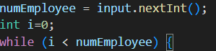

-the loop executed is base on your input at numEmployee,if you input 2,it will loop twice,and so on

2. In this code,



What actually happens if the 'position' variable contains the value 'DIRECTOR'? What is

the use of CONTINUE within the loop structure?

-A continue statement" is a control flow statement used in programming to skip the current iteration of a loop and proceed to the next iteration

3. Why is the 'i++' iteration component placed in the middle, not at the end of the while

block? Move 'i++' to the end of the while block, then run the program again by entering

'DIRECTOR' as the position for the first employee. What happens? Explain!

-it will loop because at the statement director its write continue and it will return over and over again because its count 0 unless you type other position it will stop

4. Modify the program code to handle invalid positions like the following example:

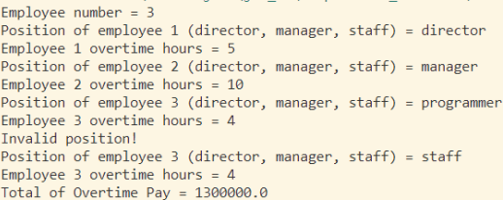

5. Commit and push the changes to GitHub.

- <https://github.com/FebrianArkaSamudra/ProjectLatDasPro/blob/main/WhileOvertimePay.java>

**Questions 3**

1. What is the use of the BREAK within the loop syntax?

- A "break statement" is a control flow statement used in programming languages to exit or terminate a loop prematurely, before it reaches its natural exit point

2. Modify the program so that if the number of leave days requested is greater than the

remaining entitlement, the program does not stop, allowing the user to enter the

number of days according to the entitlement.

- 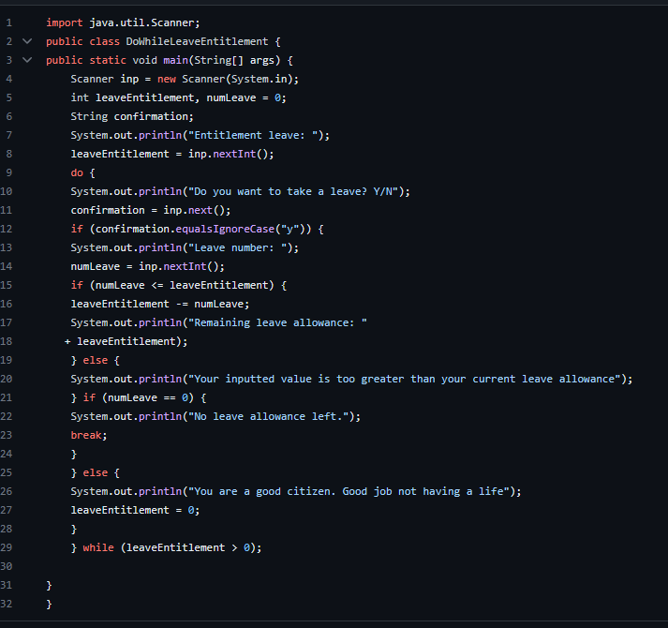

3. Commit and push the program code to GitHub.

- [Modified no 2 · FebrianArkaSamudra/ProjectLatDasPro@62f6ce5 (github.com)](https://github.com/FebrianArkaSamudra/ProjectLatDasPro/commit/62f6ce546bbdf88bdece3c1b99a161ed2ac76521)

4. When typing "t" as the confirmation input, what happens? Why?

- Since the while conditions at the end is leaveEntitlement > 0 As long as the value of leaveEntitlement is greater than 0 the program will always loop at the start of the while loop statement due to the condition not being met

5. Modify the program code so that when the user enters "t" as the confirmation input, the

program will stop.

-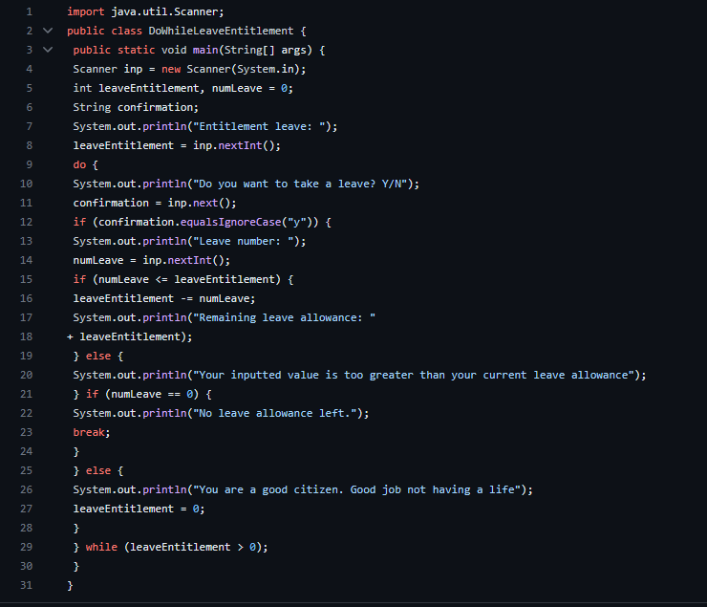

6. Commit and push the program code to GitHub.

-[Modified no 5 · FebrianArkaSamudra/ProjectLatDasPro@fe566fc (github.com)](https://github.com/FebrianArkaSamudra/ProjectLatDasPro/commit/fe566fcc2326af67b35b09bbd6ba462f70cb0049)